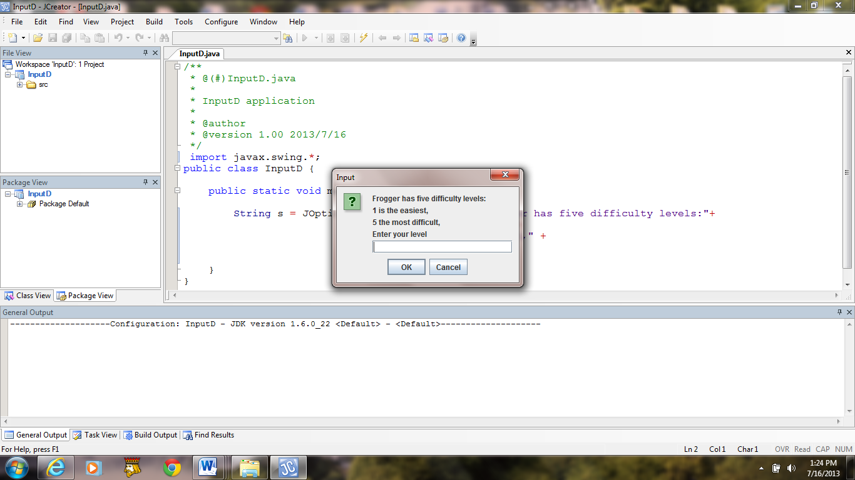

**Figure 2.7 An Input dialog box before the user enters input.**